#### Earth Observation Layers

[Echoes - Land Management](https://echoes-platform.eu/app/main/map-view)

20 Steps

Go to <https://echoes-platform.eu/>

1 - Earth observation Layers

In the layer list you will see the drop down for Earth Observation

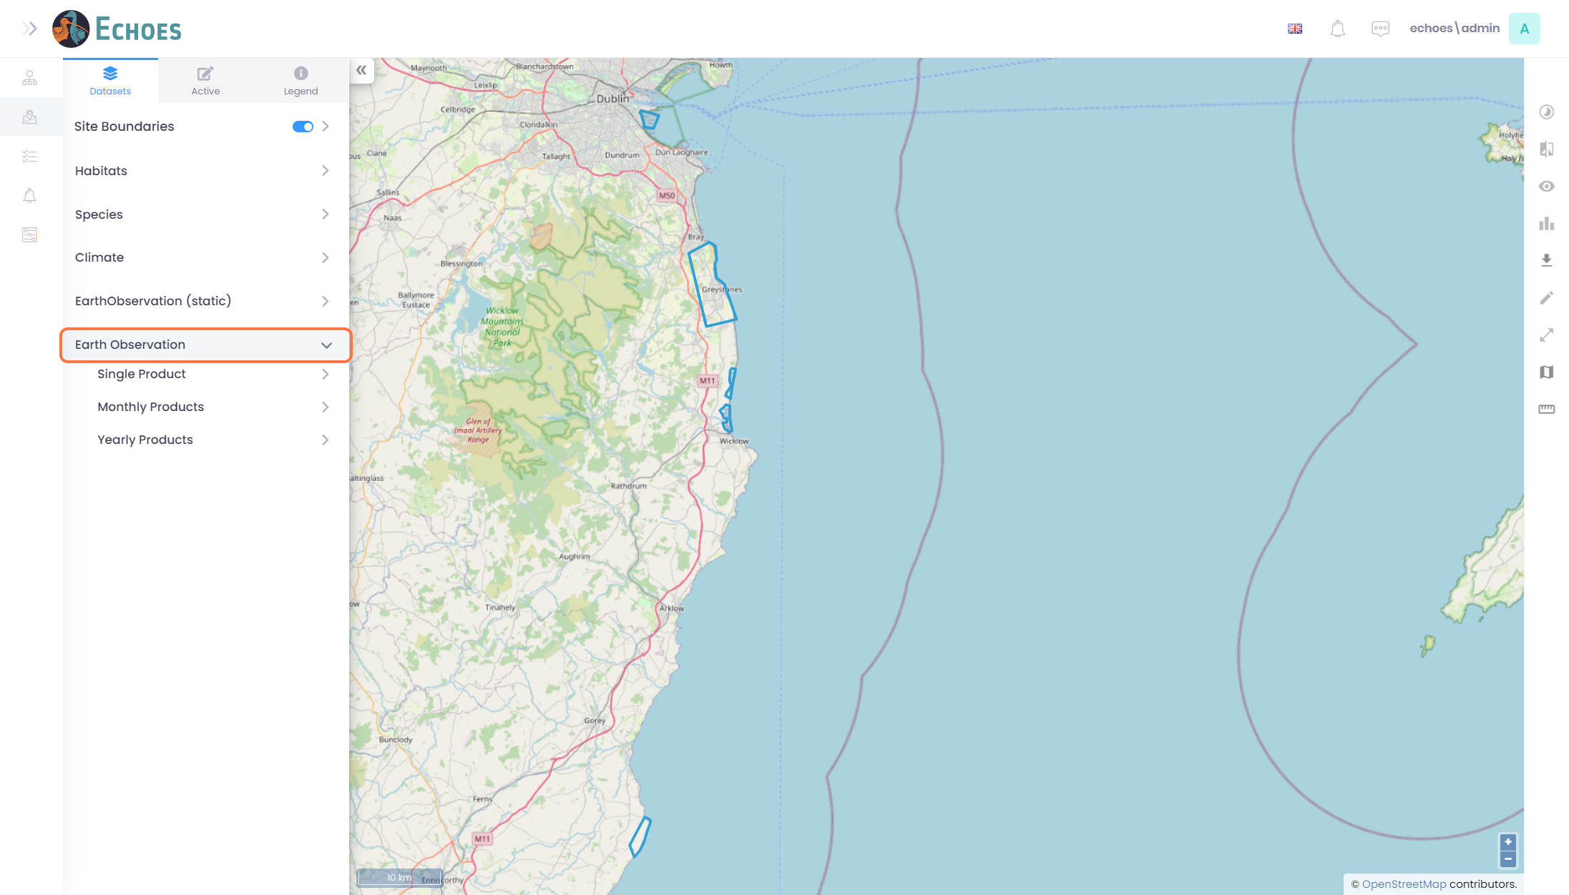

2 – Product Dates

Inside the drop down you will see 3 folders,

* **Single** - A new image for a chosen product whenever it is available.
* **Monthly** - 1 image per month for a chosen product.
* **Yearly** - 1 image per year for a chosen product.

For this example i will be using Monthly products.

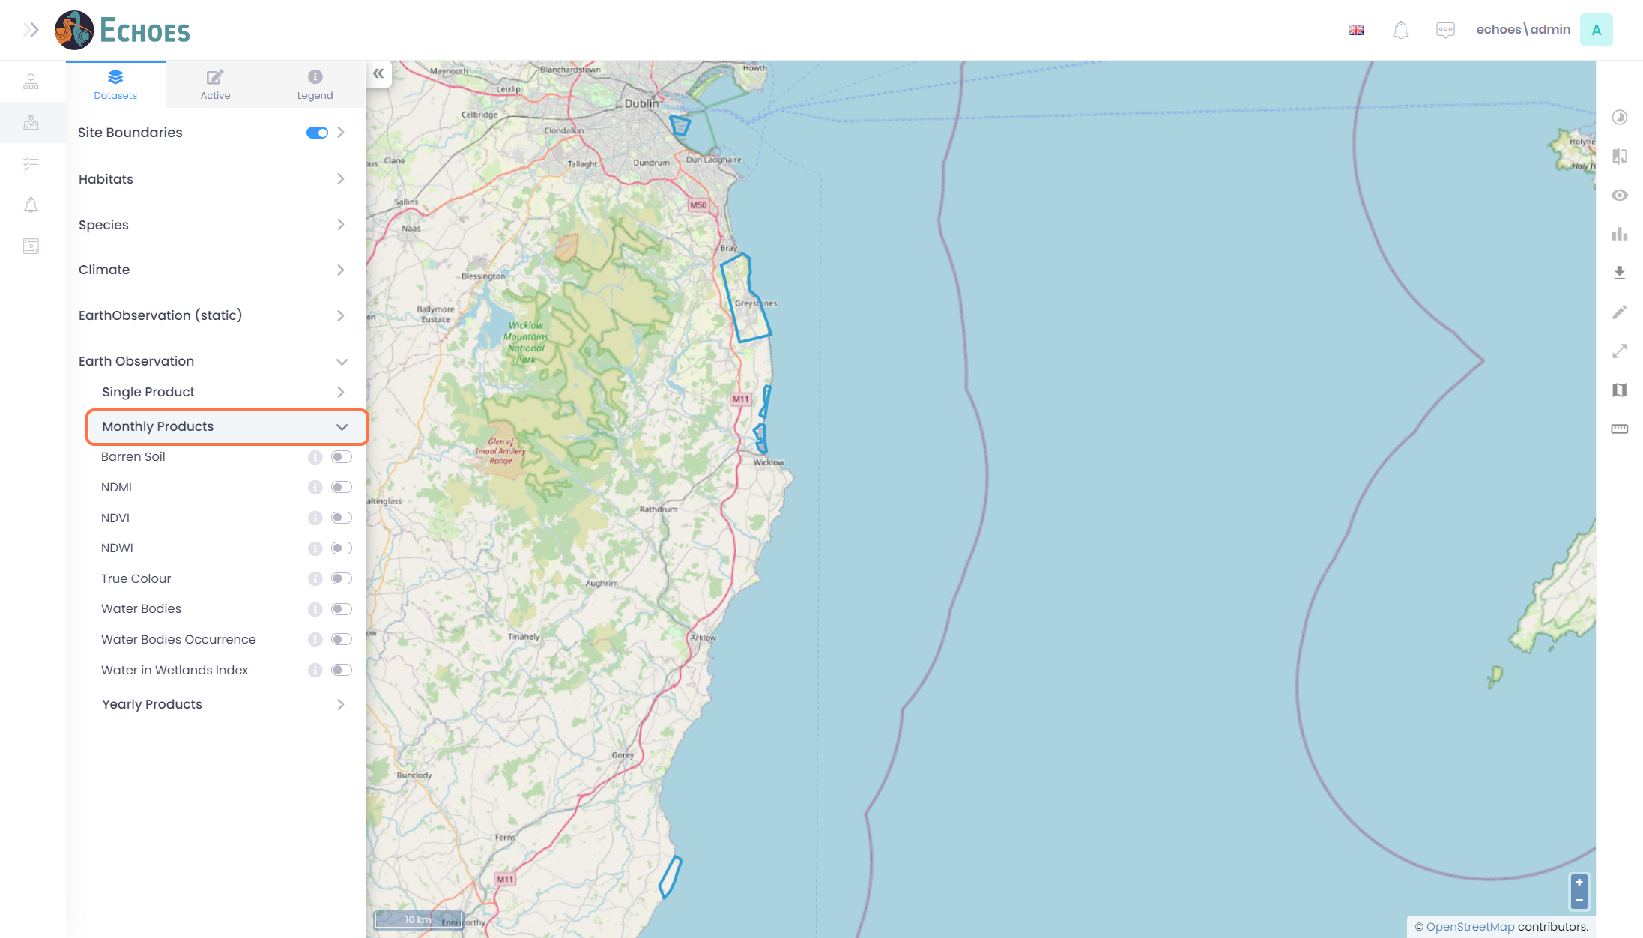

3 - More Information (1/4)

To see more information about a product, click on the 'i' icon.

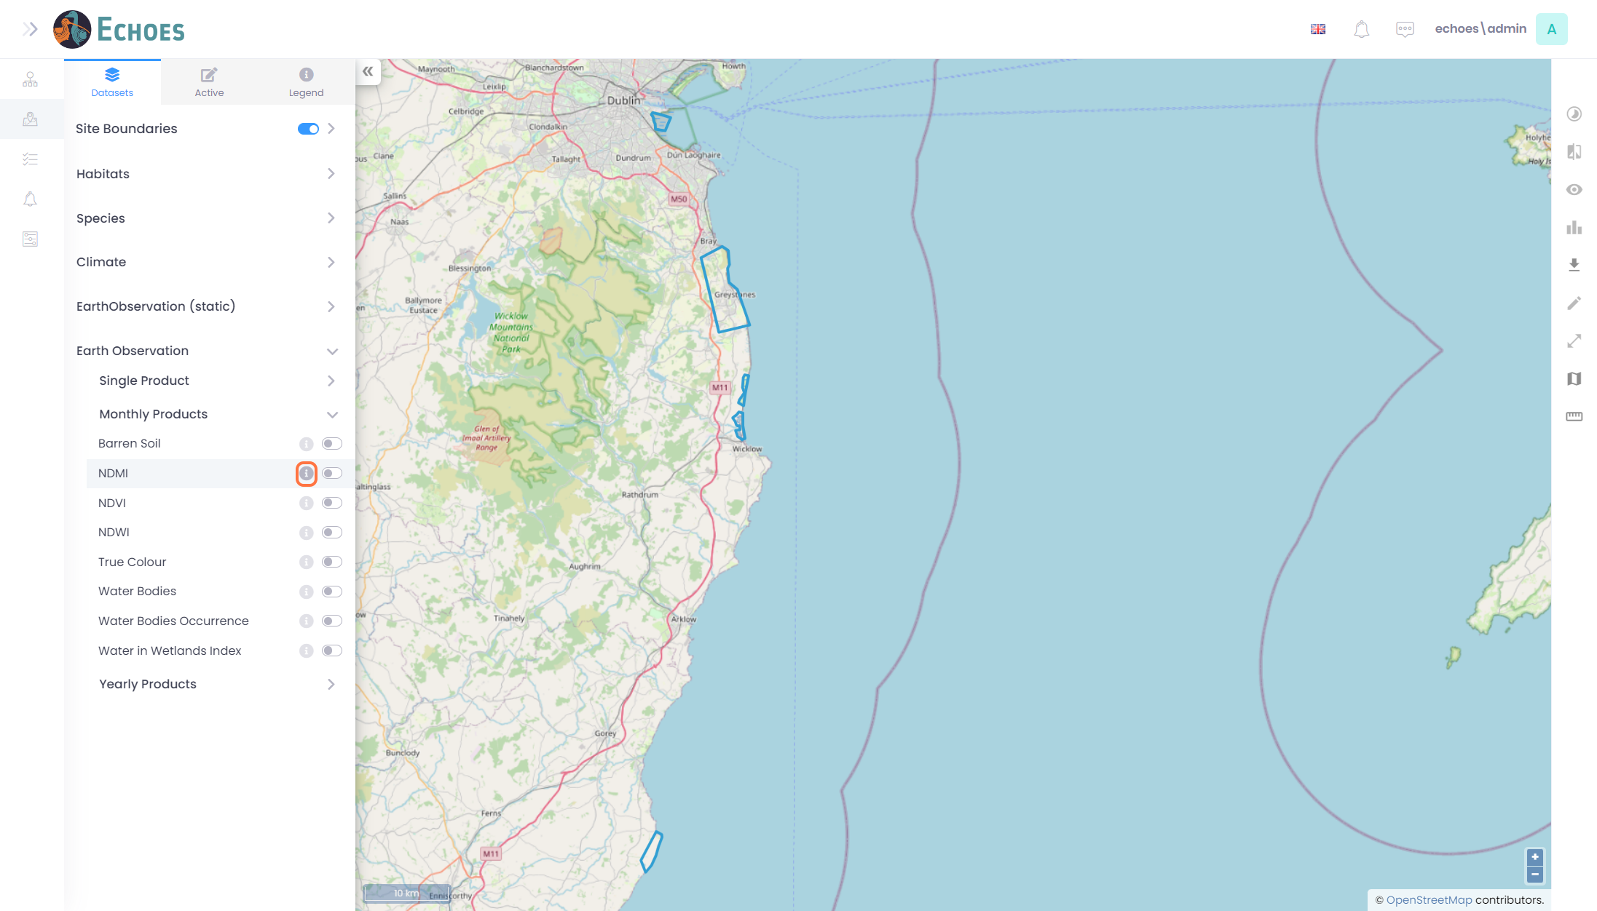

4 - More Information (2/4)

You will see a pop up showing more information about that layer.

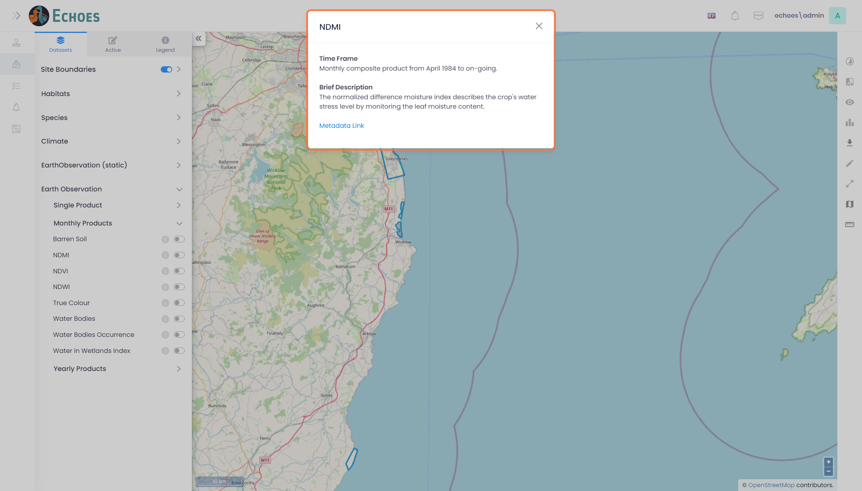

5 - More Information (3/4)

You have the option to click the link 'Metadata Link'

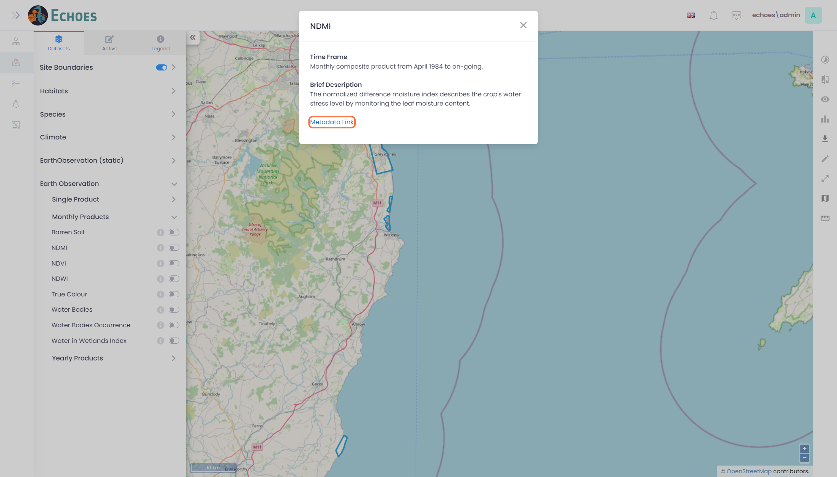

6 - More Information (4/4)

This will open a link in another tab with a deeper explanation about the layer.

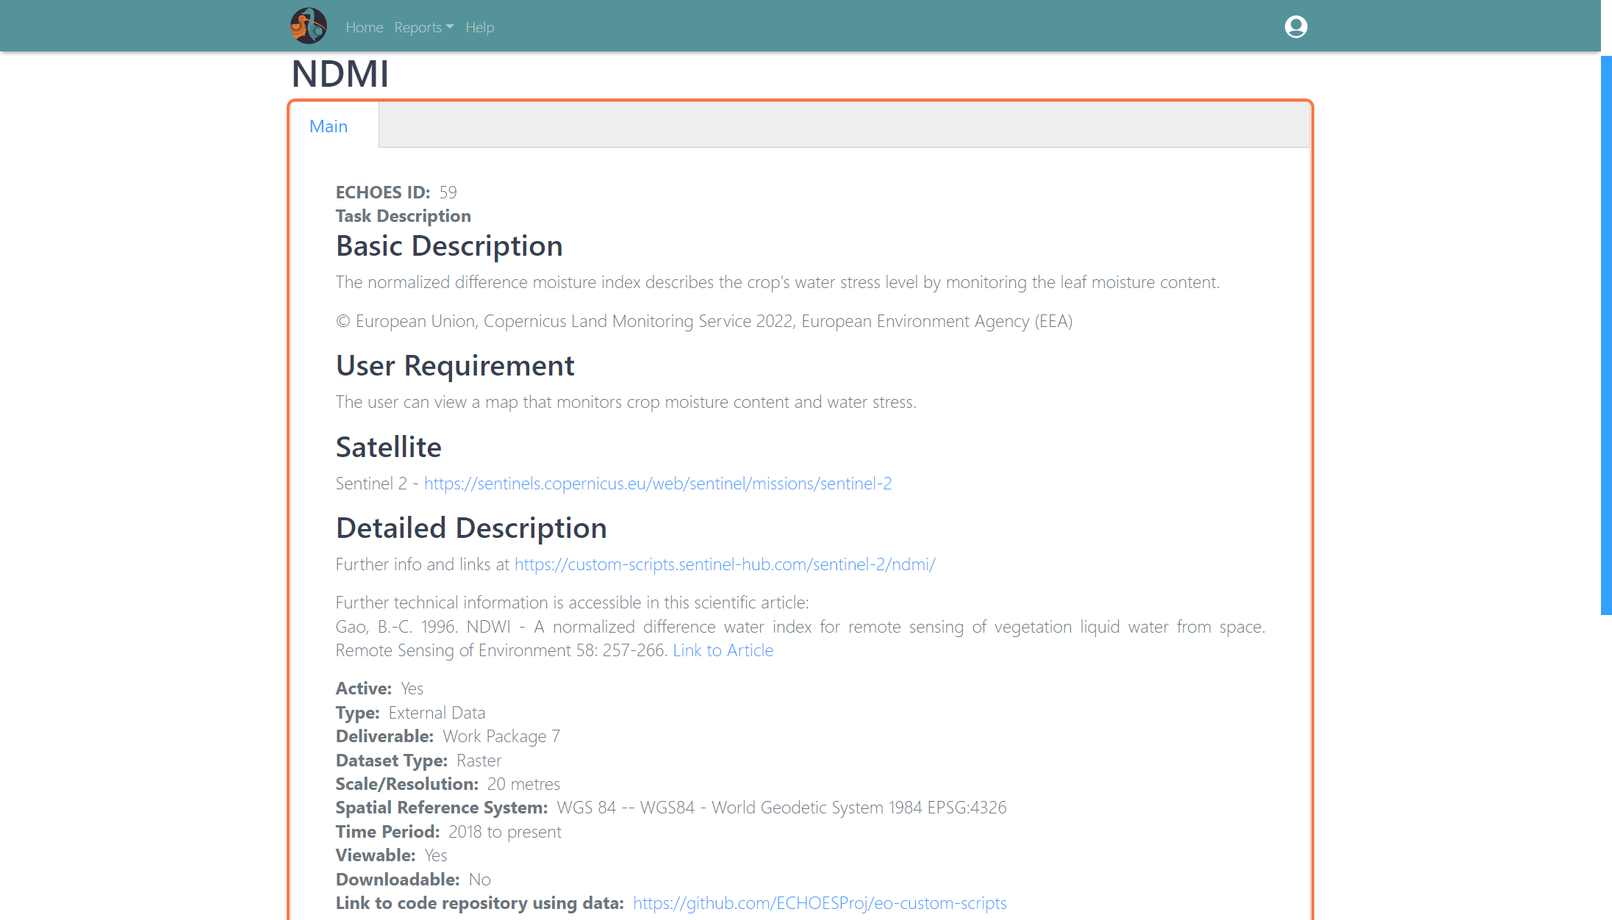

7 - Toggle on your Product

Clicking the toggle icon to turn on the layer you want to see.

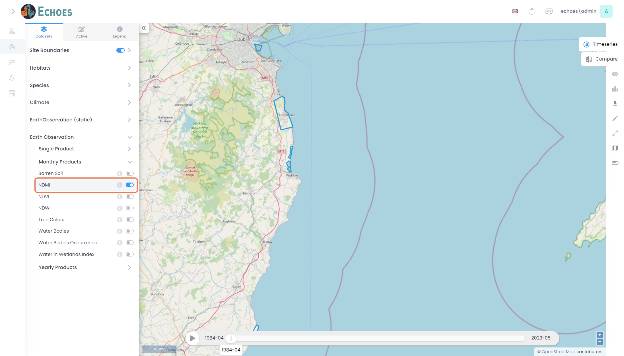

8 - Earth Observation Layer Visible

You will now see the processed Earth Observation layer on the map, for the sites you have previously created.

**Note:** The processing is done on a nightly basis, so if you have created a site that day, you will have no images for that site until the following day.

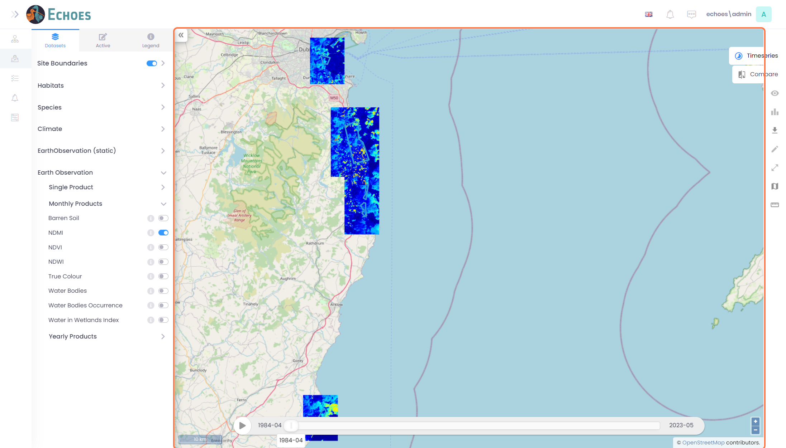

9 - Symbology (1/2)

Clicking into the Legend tab will allow you to see the symbology for the Earth Observation layer you have enabled.

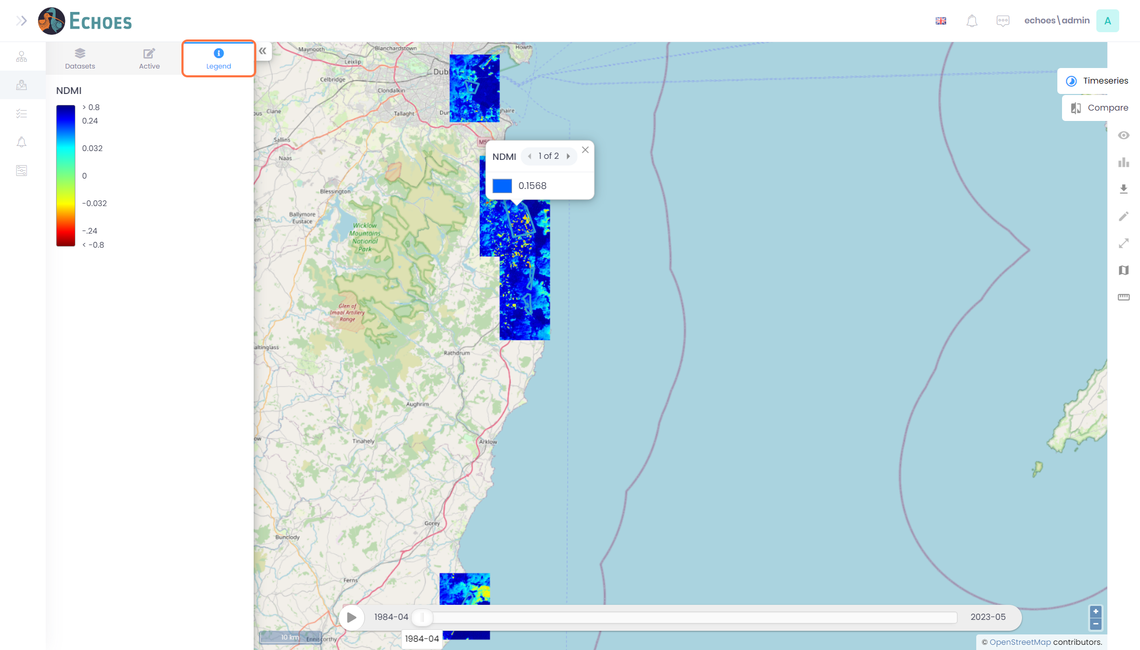

10 - Symbology (2/2)

Clicking on the map will also give you the value for that point, and its symbology.

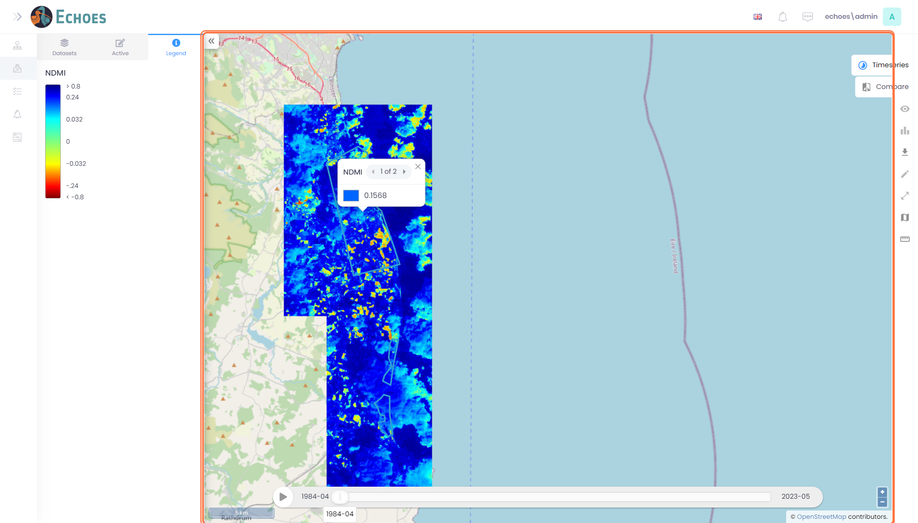

11 - Earth Observation Time Slider

Clicking the play icon or moving the slider will change the images to that chose dates corresponding image, and may change the value in the pop up.

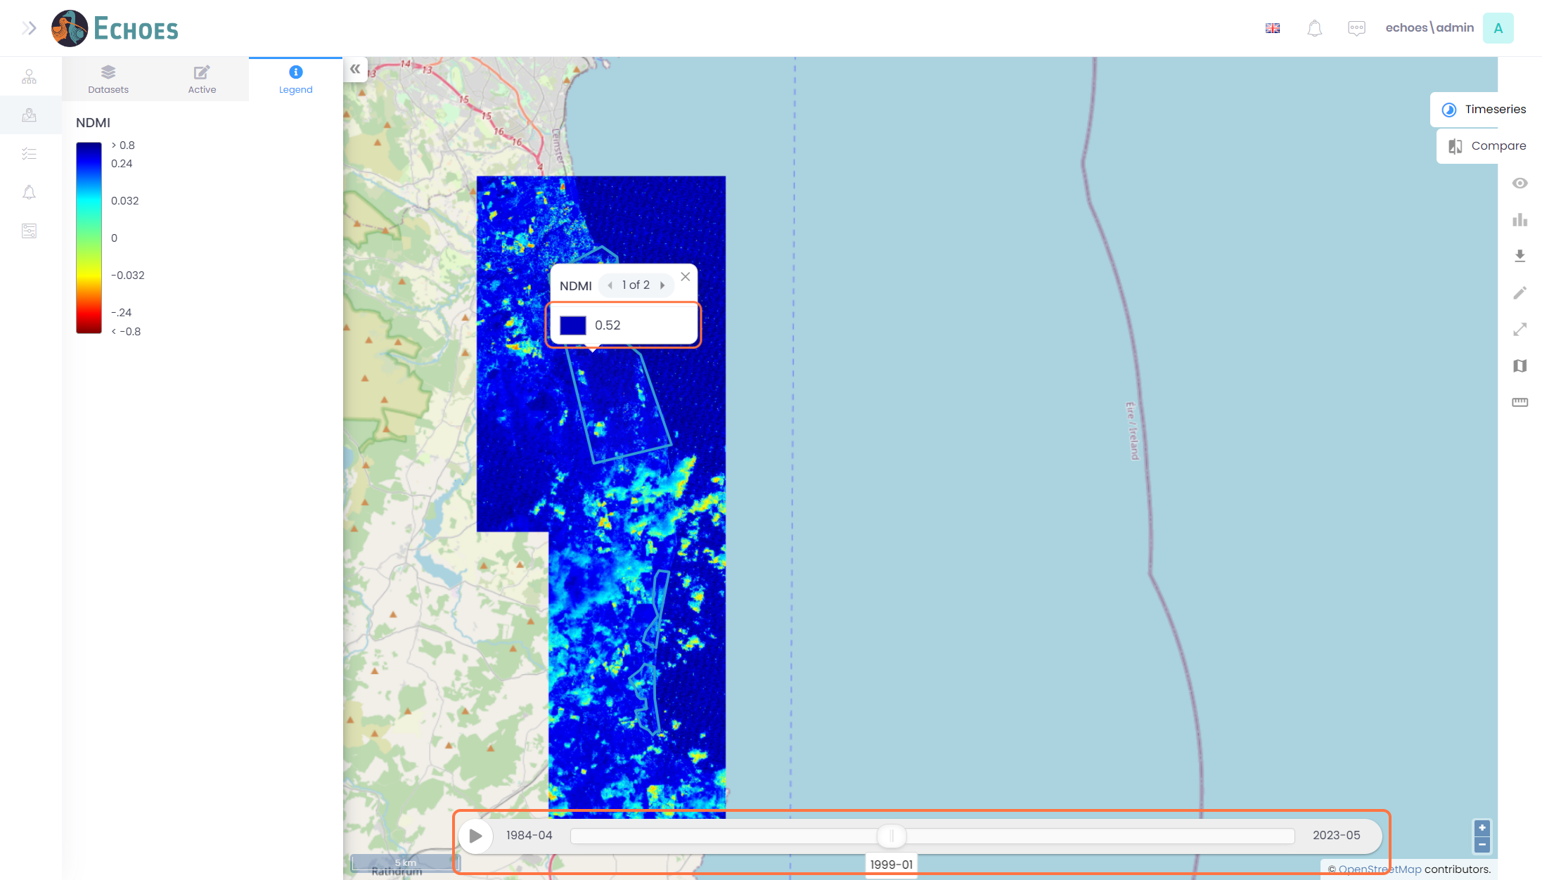

12 - Compare Earth Observation Tab

On the right-hand side, you have the 'Compare tab' clicking on this will open a side-by-side view of the Earth Observation images, with the ability to choose 2 different dates.

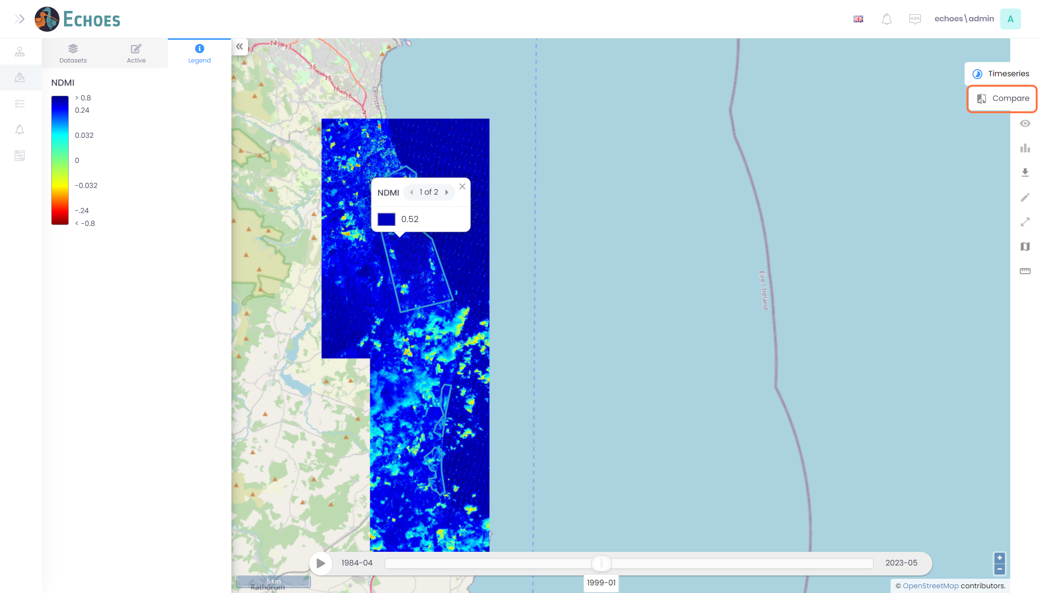

13 - Tools Available

Once you click the compare tab, you will see 2 tools available;

* **Satellite Icon** - This is where you will choose the image dates you want to see on the map
* **Differences** - This will highlight the RGB colour differences from each image.

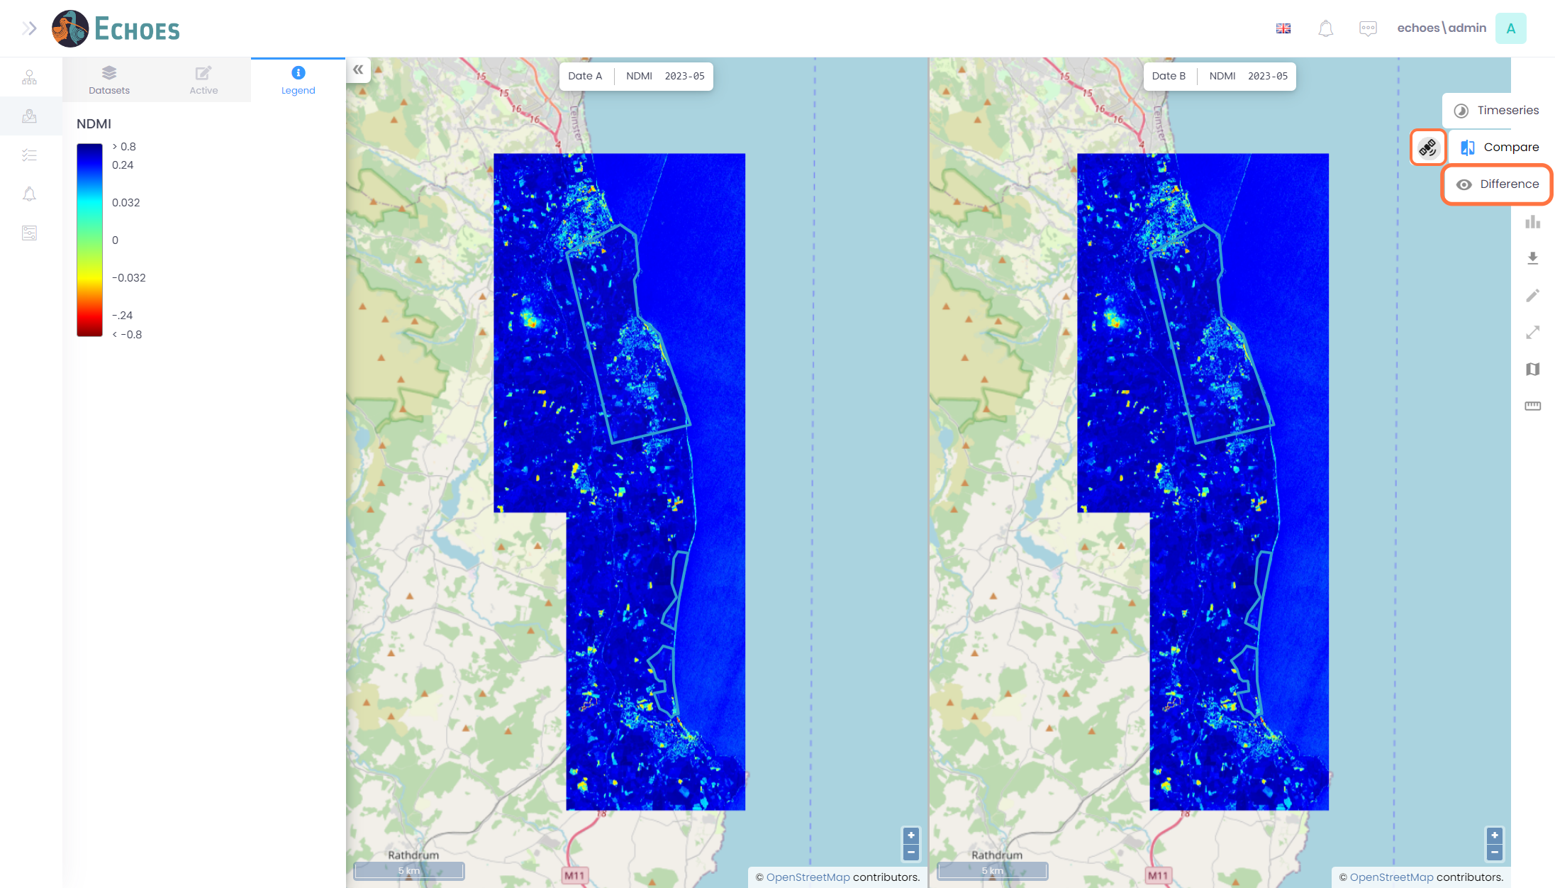

14 - Satellite Tool (1/4)

Clicking the satellite tool icon will open a pop out similar to below. Here you have 'Date A' which corresponds to the Left image on the map, and 'Date B' which corresponds to the Right image on the map.

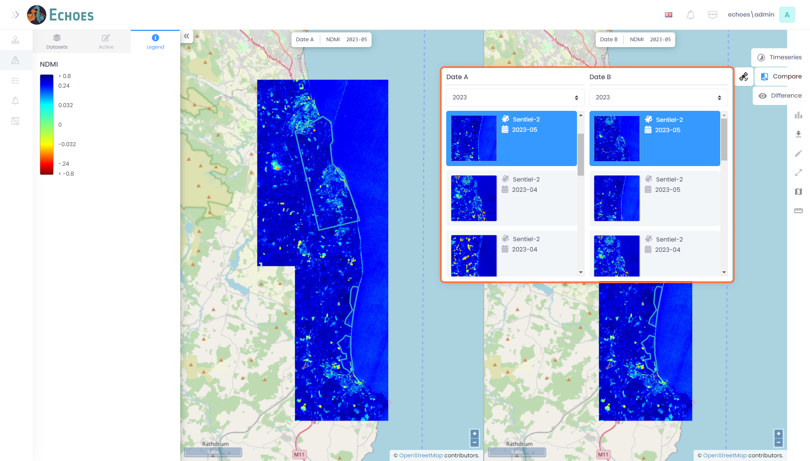

15 - Satellite Tool (2/4)

Each date for a monthly product will have a year picker drop down option which will change the list of thumbnail images to that year in the date picker lists below.

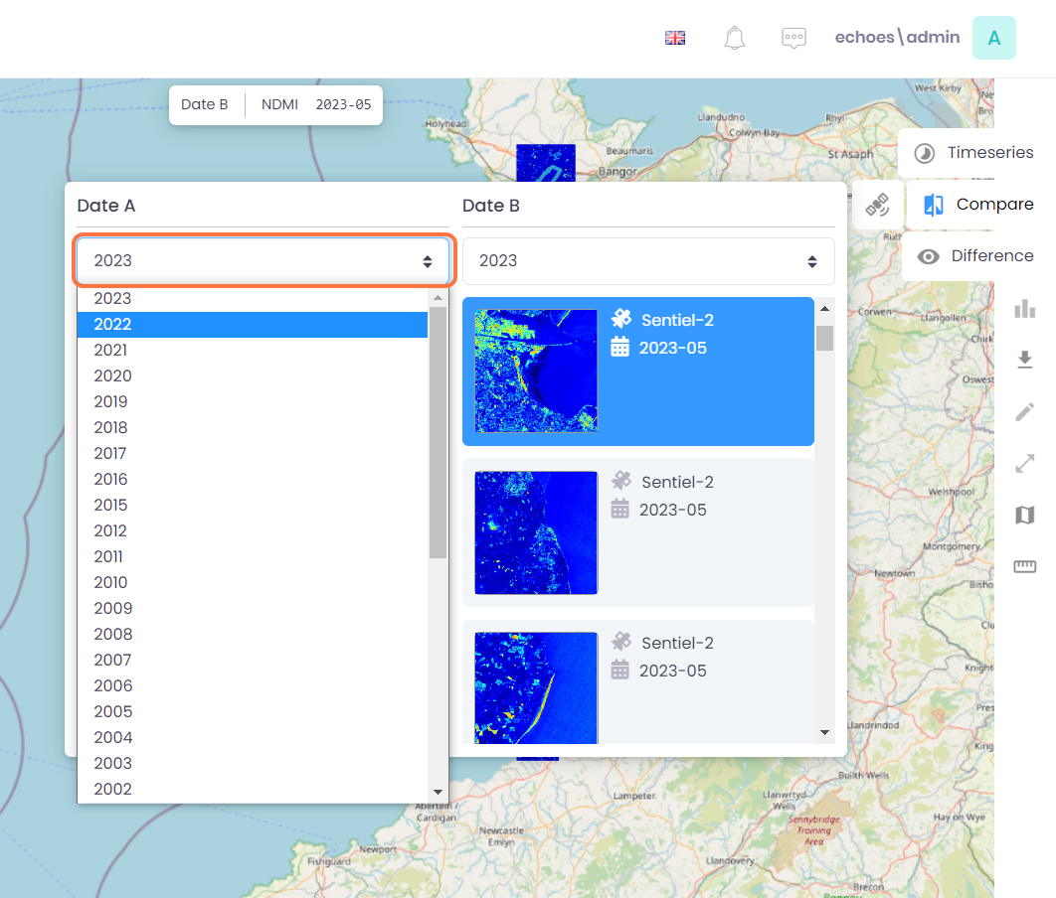

16 - Satellite Tool (3/4)

You can choose a new month from the list for that year

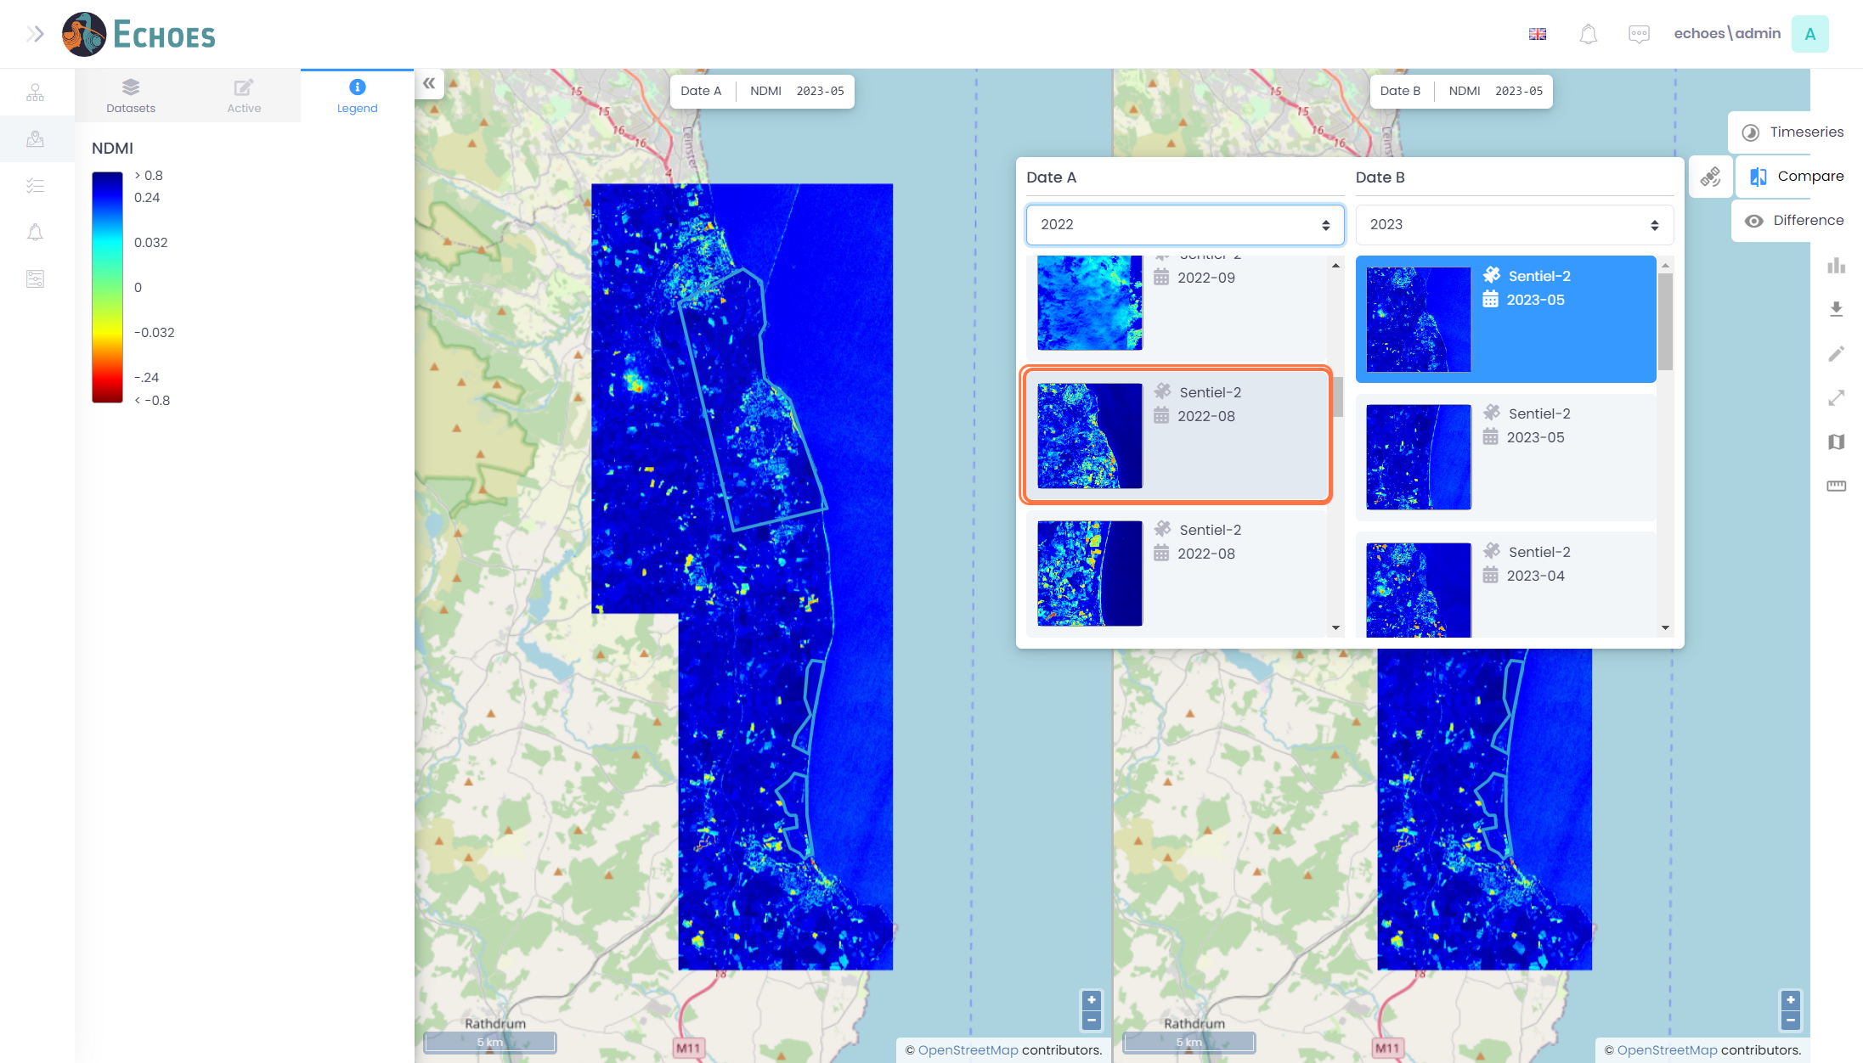

17 - Satellite Tool (4/4)

You will now see the changed image on the map view for the data you chose.

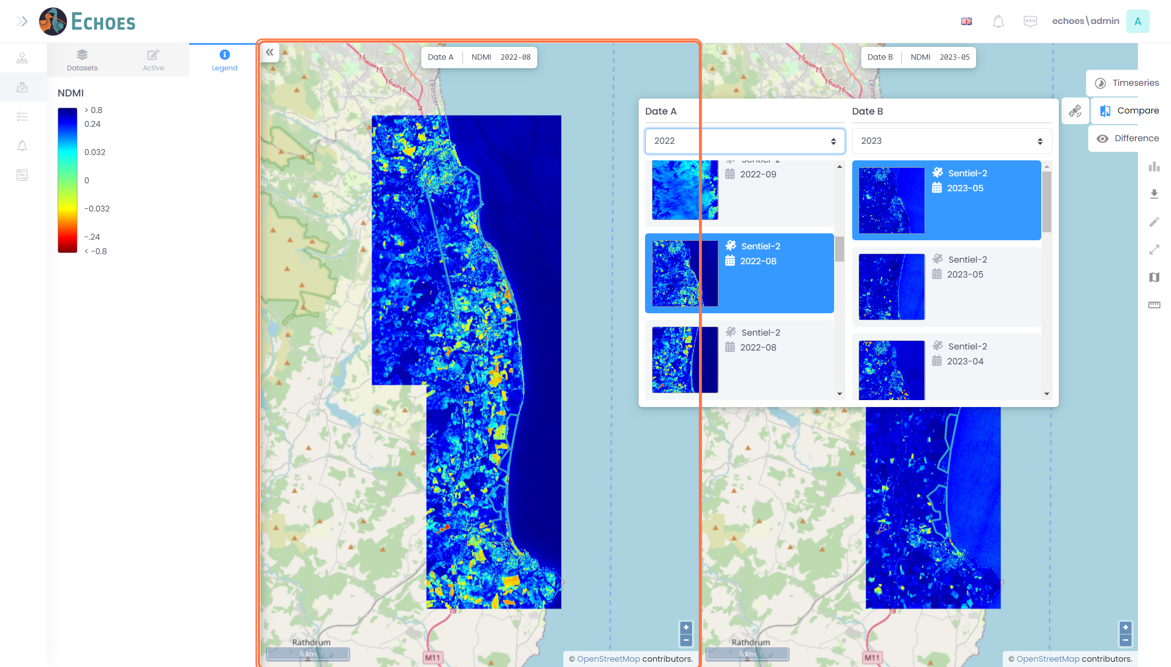

18 - Difference Tool

Clicking the difference tool will open the cog icon and clicking that icon will open a list of difference algorithms to choose from.

**Note:** When the difference tool is Active, you cannot pan around on the map. You must close the tool by clicking the tab again to pan around the map again.

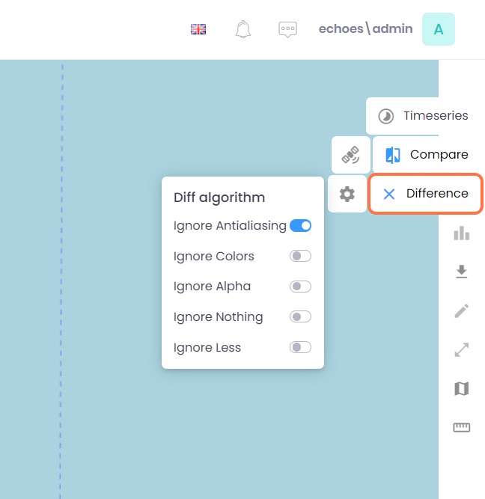

19 - Earth Observation Static Layers (1/2)

Clicking on the EarthObservation (static) drop down will give you a list of single image Earth Observation products. These will not have time series or comparison capabilities

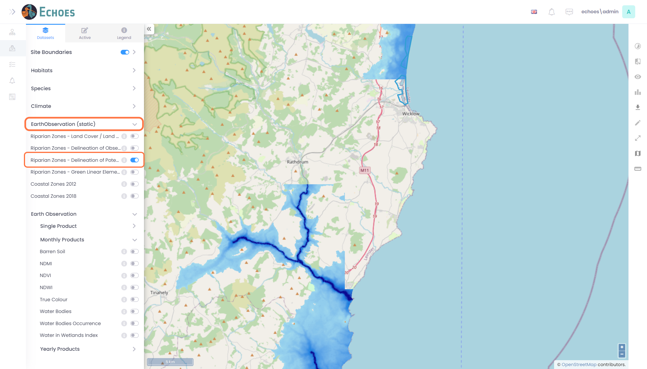

20 - Earth Observation Static Layers (2/2)

You can now see the layer selected on the map view.

